embedUR Systems
Campus Training Program – 2026
LINUX TRAINING – ASSESSMENT 3
Name : Muhesh M
College :Thiagarajar College of Engineering, Madurai.

Scenario: Automating file backup and Reporting to the system. Create a shell script called "backup_manager.sh" that performs the following tasks incorporating the concepts suggested.

Requirements:

1. Command-line Arguments and Quoting:
The script must accept three arguments: Source directory: A directory containing files to back up. Backup directory: The destination where files will be backed up. File
extension: A specific file extension to filter (e.g., .txt).Example: /backup_manager.sh"/home/user/source" "/backup" ".txt"

2. Globbing:
The script should use globbing to find all files in the source directory matching the provided file extension.
3. Export Statements:
Use export to set an environment variable BACKUP_COUNT, which tracks the total number of files backed up during the script execution.
4. Array Operations:
Store the list of files to be backed up in an array.
Print the names of these files along with their sizes before performing the backup.

5. Conditional Execution:
If the backup directory does not exist, create it. If creation fails, exit with an error.
If the source directory is empty or contains no files matching the extension, exit with a message.
If a file already exists in the backup directory with the same name, only overwrite it if it is older than the source file (compare timestamps).

6. Output Report:
After the backup, generate a summary report displaying:
Total files processed.
Total size of files backed up.
The path to the backup directory.
The report should be saved in the backup directory as backup_report.log.

BASH SCRIPT backup_manager.sh

#!/bin/bash

shopt -s nullglob
echo "The Source Directory is : $1"
echo "The Destination Directory is : $2"
echo "The File Extension to Backup is : $3"
export BACKUP_COUNT=0
TOTAL_SIZE=0
declare -a files_array

# Checking Whether the Source File exists or not

if [ ! -d "$1" ];then
{ echo "The Source File does not Exists : $1" ; exit 1;}
fi

# Globbing and storing the Files in the Array

for file in "$1"/*"$3"; do
files_array+=("$file")
done

# Exit if no such Matching Files with Extension found

if [ "${#files_array[@]}" -eq 0 ]; then
{ echo "No Files Exist Matching the Extension : $3" ; exit 1; }
fi

# Printing files and their sizes before Backup

echo "Files and their sizes:"
for file in "${files_array[@]}"; do
ls -lh "$file"
done

# Create backup directory if does not exists

if [ ! -d "$2" ]; then
mkdir -p "$2" || { echo "Failed to Create Directory : $2"; exit 1; }
fi

# Calculating Sizes of Each File and finding total size of
backup files

for file in "${files_array[@]}"; do
dest="$2/$(basename "$file")"

size=$(stat -c %s "$file")

TOTAL_SIZE=$((TOTAL_SIZE + size))

# Checking Whether already the File exists in the backup
directory , if exists comparing the time stamps of both files

if [ -f "$dest" ]; then

if [ "$file" -nt "$dest" ]; then
cp "$file" "$dest"
BACKUP_COUNT=$((BACKUP_COUNT + 1))
fi

else
cp "$file" "$dest"
BACKUP_COUNT=$((BACKUP_COUNT + 1))
fi
done

# Output reports

{
echo "Backup Report"
echo "Total files processed : ${#files_array[@]}"
echo "Total files backed up : $BACKUP_COUNT"
echo "Total size backed up : $TOTAL_SIZE bytes"
echo "Backup directory : $2"
echo "Backup completed on : $(date)"
} > "$2/backup_report.log"

echo "Backup completed successfully."
echo "Report saved at: $2/backup_report.log"

Test Case -1 The Source File Exists and Backup File Does not Exists

1.Terminal Commands:

- touch backup_manager.sh
- chmod +x backup_manager.sh
- gedit backup_manager.sh
- ./backup_manager.sh “/home/muchu/Documents” “/home/muchu/embedur_linux/Module_3/backup” “.txt”

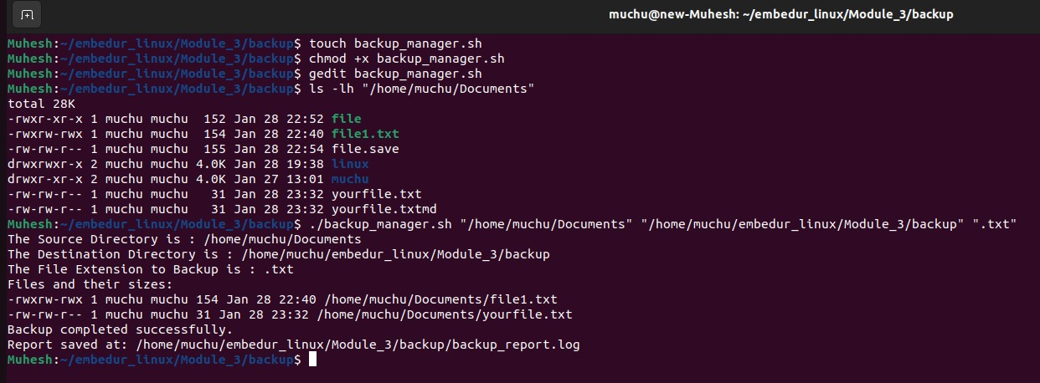
backup_report.log Output
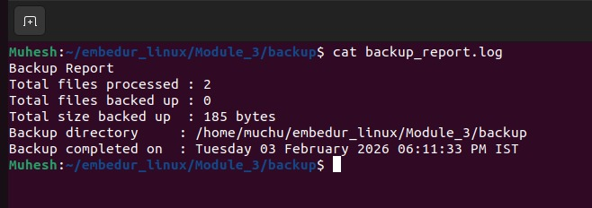

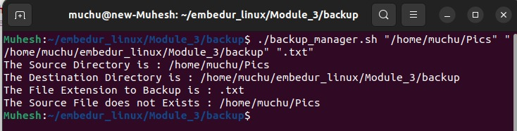
Test Case -2 The Source File Does Exists

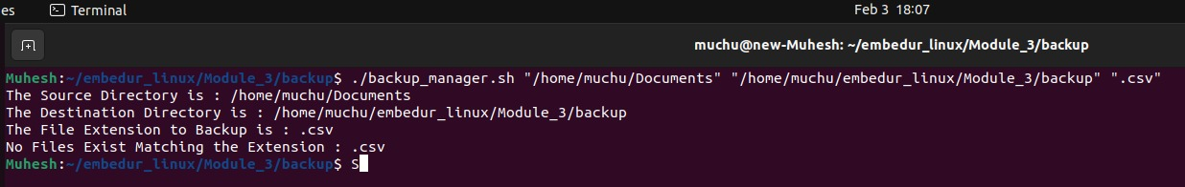
Test Case -3 There are no files with Matching given File Extension

